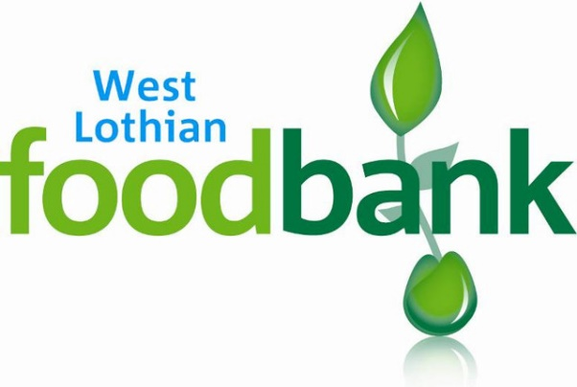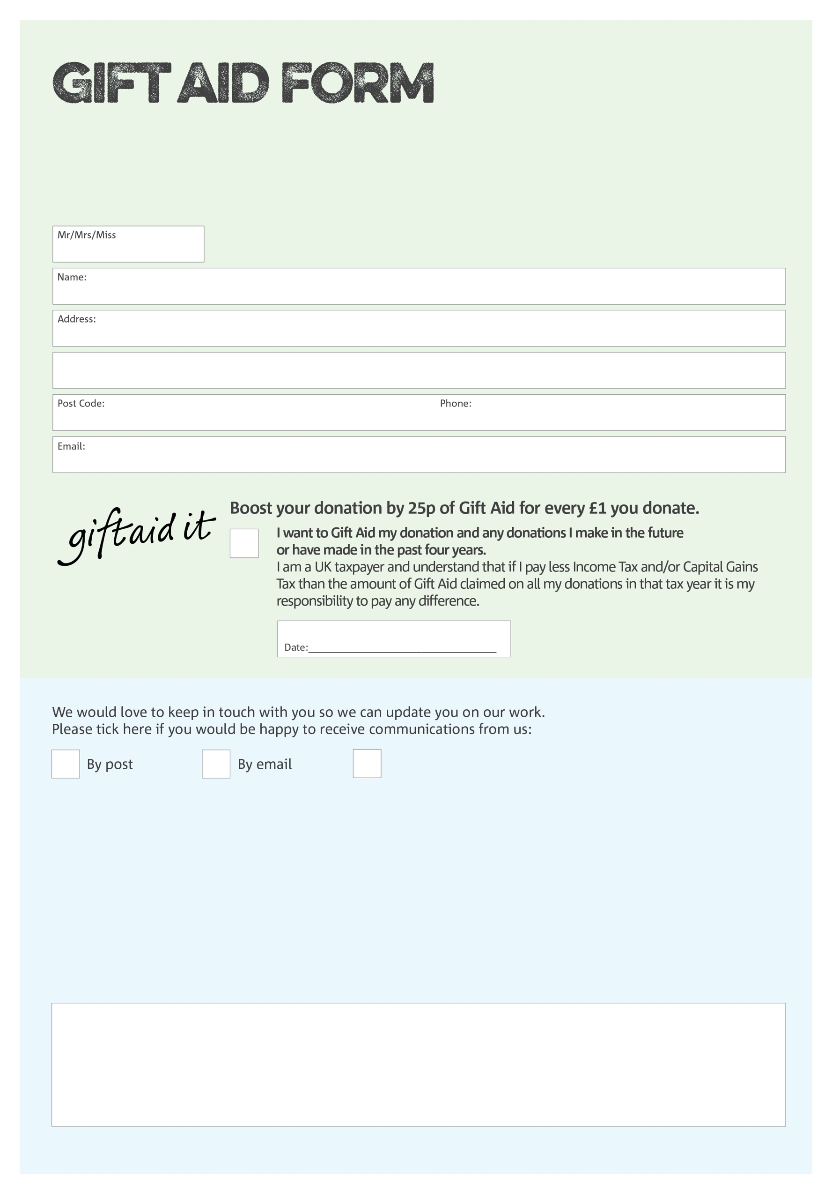

By filling in this form West Lothian Foodbank will receive an extra 25p for every £1 you give at no extra cost to you. Thank you!

We would love to know why you have chosen to donate to West Lothian Foodbank. If you would like to share your motivation let us know below:

You can change your preferences any time by contacting us on 01501 229307 or emailing us at

info@westlothian.foodbank.org.uk

**Data protection**

‘West Lothian Foodbank is committed to protecting your privacy and will process your personal data in accordance with current Data Protection legislation. West Lothian Foodbank collects information to keep in touch with you and supply you with information relating to our work. To unsubscribe from our newsletter, send a message to the email address above with the word unsubscribe in the subject line. A full data privacy statement for financial donors is available from the foodbank on request.’

I do not wish to receive future communications from West Lothian Foodbank

West Lothian Foodbank (SCIO) is a Scottish Charitable Incorporated Organisation NumberSC0048112. Registered in Scotland