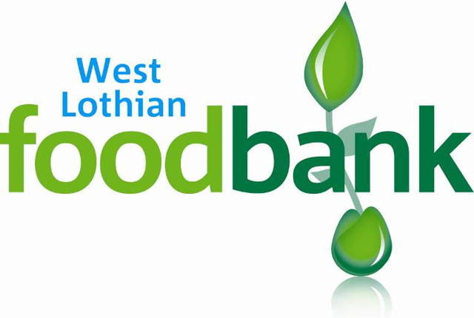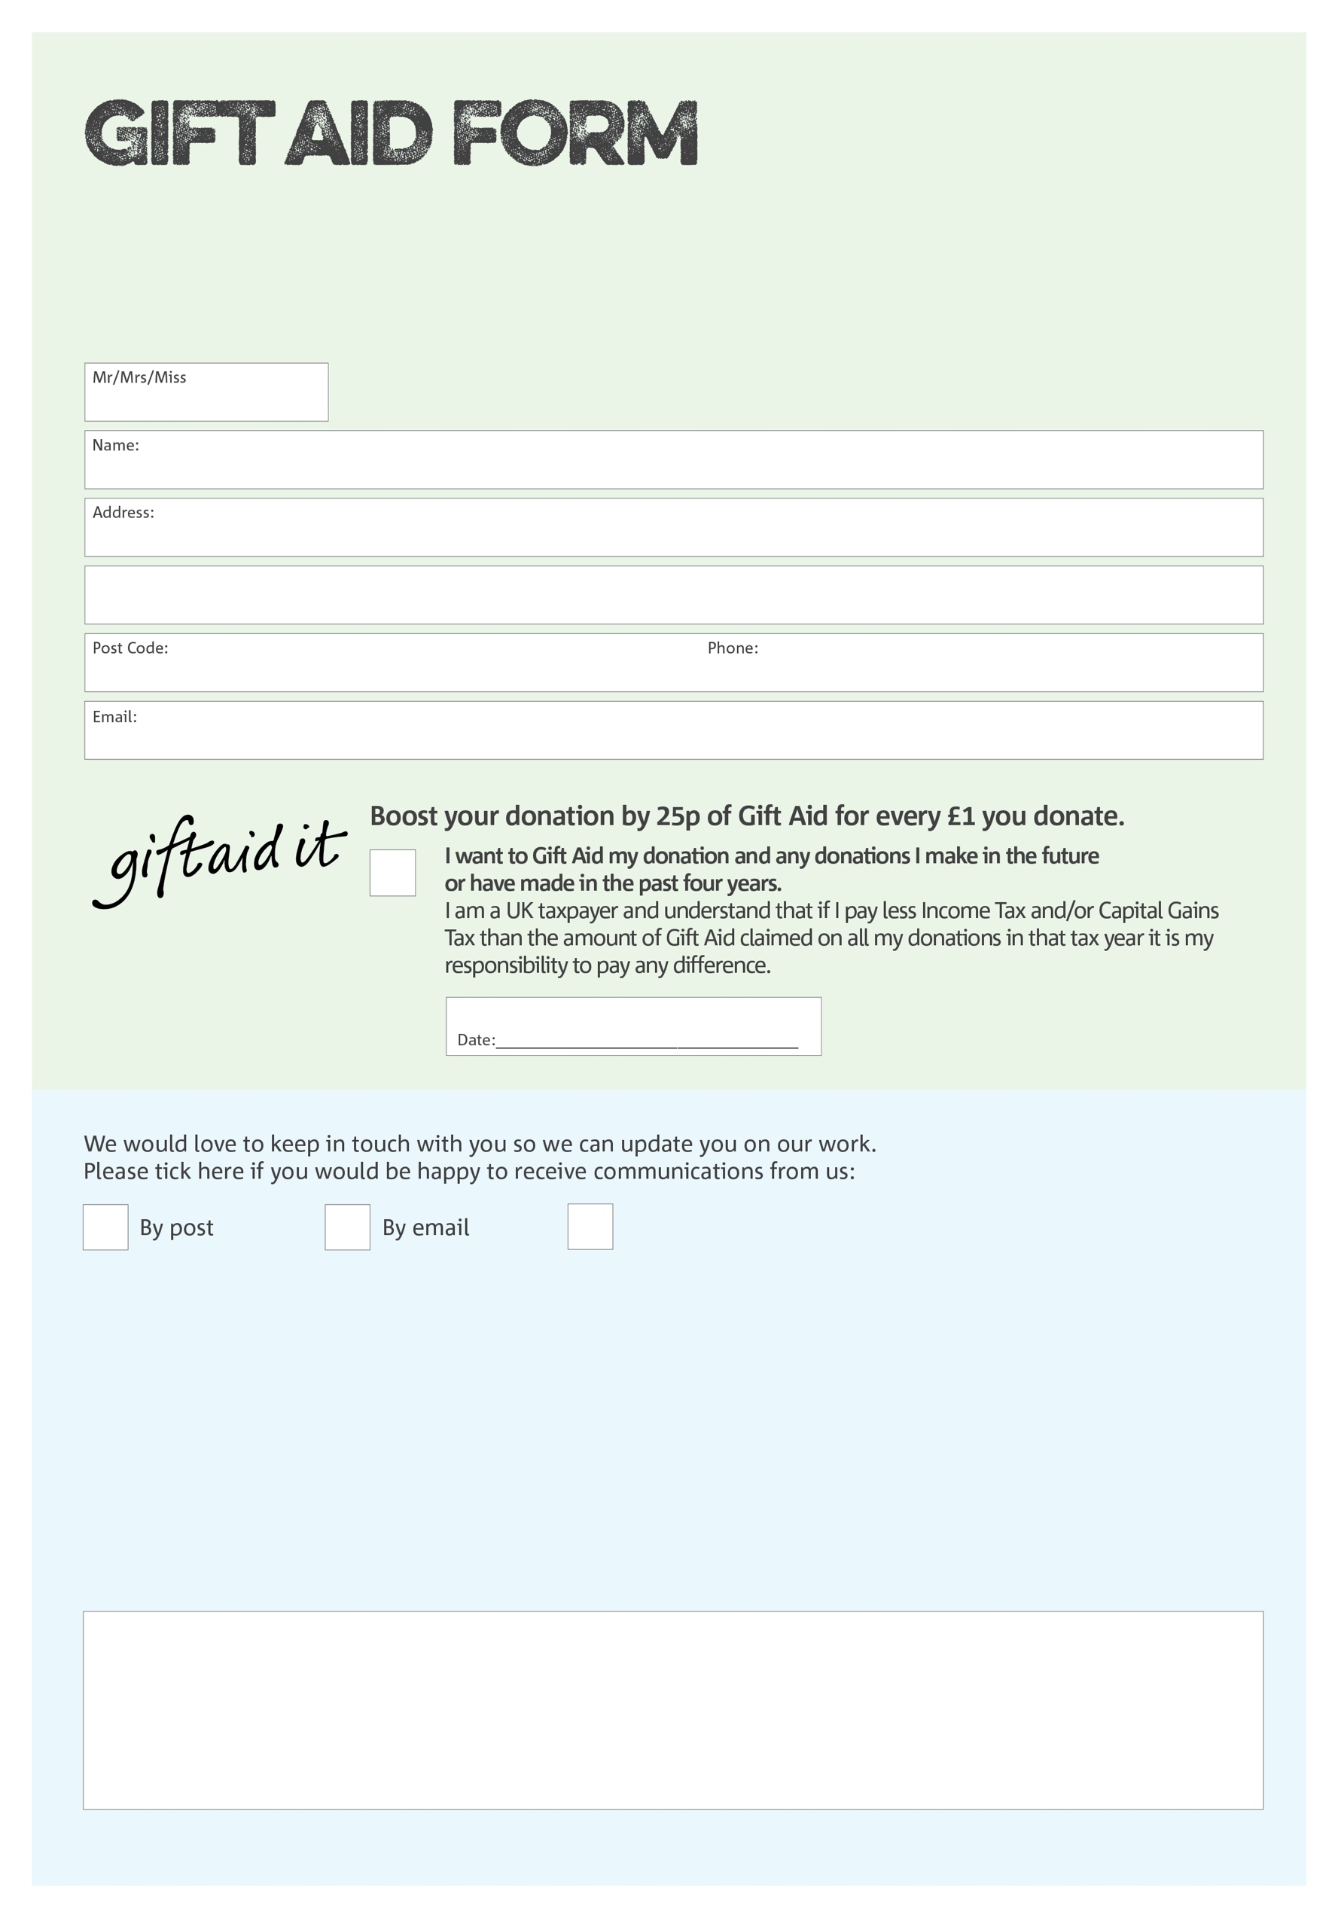

By filling in this form West Lothian Foodbank will receive an extra 25p for every £1 you give at no extra cost to you. Thank you!

You can change your preferences any time by contacting us on 01501 229307 or emailing us at

info@westlothian.foodbank.org.uk

I do not wish to receive future communications from XXXX Foodbank

**Data protection**

West Lothian Foodbank is committed to protecting your privacy and will process your personal data in accordance with the Data Protection Act 1998. West Lothian Foodbank collects information to keep in touch with you and supply you with information relating to our work. West Lothian Foodbank will never sell or pass your details to anyone who isn’t directly working on our behalf.

We would love to know why you have chosen to donate to West Lothian Foodbank. If you would like to share your motivation let us know below:

West Lothian Foodbank (SCIO) is a Scottish Charitable Incorporated Organisation NumberSC0048112. Registered in Scotland