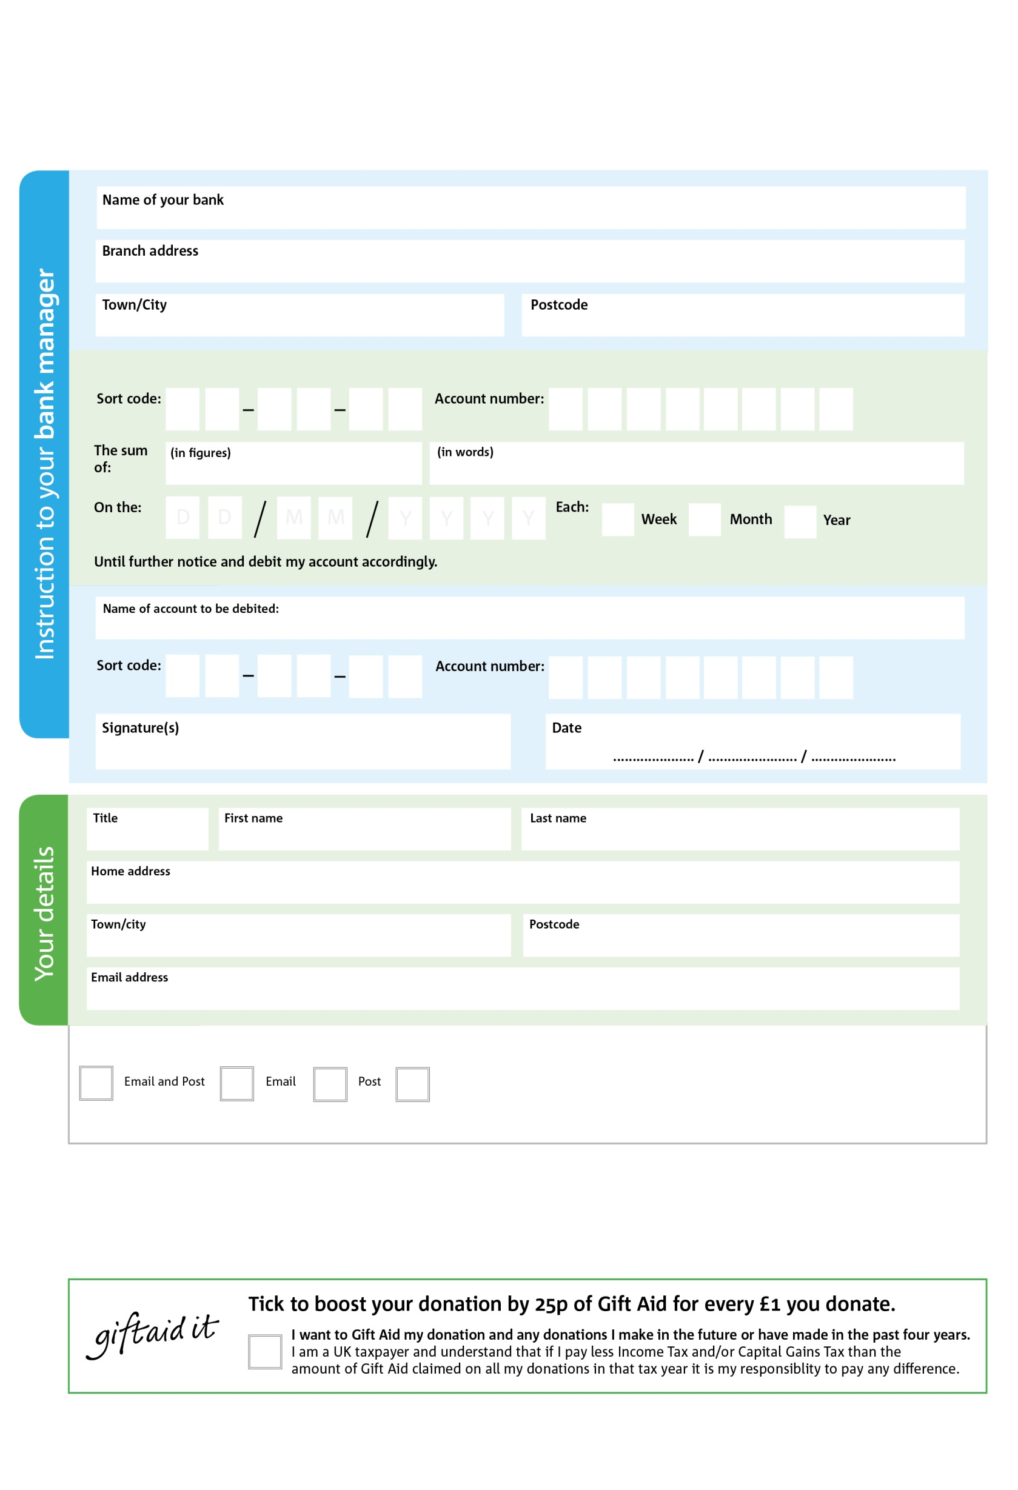

West Lothian Foodbank (SCIO) is registered in Scotland as a Scottish Charitable Incorporated Organisation (SCIO), No SC048112.

**POSTAL ADDRESS: West Lothian Foodbank (SCIO), Unit 5 Heron Square, Deans Ind Estate, Livingston, EH54 8QY**



V



V



V



V



V



V



V



V

**Please pass this form onto the foodbank, using the foodbank’s address at the bottom of this form, who will save a copy for their records.   
They will then send it onto your named bank or building society.**

We would love to keep you up to date with information about the West Lothian Foodbank. Please tick your preference:

You can change your preferences any time by contacting us on 01501 229307 or emailing us at info@westlothian.foodbank.org.uk

I do not wish to receive future communications from the West Lothian Foodbank

Please pay the West Foodbank,

**Data protection**

*The West Lothian Foodbank (SCIO) is committed to protecting your privacy and will process your personal data in accordance with current Data Protection legislation. The West Lothian Foodbank (SCIO) collects information to keep in touch with you and supply you with information relating to our work. To unsubscribe from our newsletter, send a message to the email address above with the word unsubscribe in the subject line. A full data privacy statement for financial donors is available from the foodbank on request.*

**Standing Order Mandate**

**westlothian.foodbank.org.uk**

You can change your preferences any time by contacting us on XXXXXXXXXXX or emailing us at XXXX@XXXXXXXXXX.foodbank.org.uk

I do not wish to receive future communications from XXXXXX Foodbank